Hazelhurst Community Supported Agriculture Co-operative
Public Meeting:
Can we take your order?
Monday 5th July 2010, 7.00pm for a 7.30pm formal start.
The Grapevine Centre, at the Church of the Nazarene,
Northcote Rd, Heeley, S2 3AT.

Please bring cakes and snacks to share for the first half hour, tea will be provided.

• Hear how Community Supported Agriculture works
and how other CSAs manage their projects
• Tell us what you want from this project - in an
interactive way
• Find out how you can be involved
• Hear about the emerging membership offer.
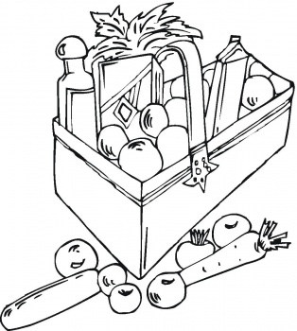
This is an exciting time for the project - come along and find out more!

For further information about the project and the wider transition movement, please see these links:

General information: http://hazelhurst.coop/
Email: committee@hazelhurst.coop
Hazelhurst Community Supported Agriculture Co-operative
Public Meeting:
Can we take your order?
Monday 5th July 2010, 7.00pm for a 7.30pm formal start.
The Grapevine Centre, at the Church of the Nazarene,
Northcote Rd, Heeley, S2 3AT.

Please bring cakes and snacks to share for the first half hour, tea will be provided.

• Hear how Community Supported Agriculture works
and how other CSAs manage their projects
• Tell us what you want from this project - in an
interactive way
• Find out how you can be involved
• Hear about the emerging membership offer.
This is an exciting time for the project - come along and find out more!

For further information about the project and the wider transition movement, please see these links:

General information: http://hazelhurst.coop/
Email: committee@hazelhurst.coop

